GRAPH NEURAL NETWORK ANALYSIS FOR SCALABLE FAKE PROFILE DETECTION AND BOTNETS
Design and Implementation
Department of Computer Science and Engineering, TKR College of Engineering & Technology
Batch A9 (CSE-A) · Academic year [ACADEMIC YEAR]
Table 1: Project team
S.No. | Student name | Roll number
1 | Bijja Naga Lakshmi | 23K91A0538
2 | Divvela Srivatshav | 23K91A0564
3 | Adumulla Durga | 23K91A0504
4 | Burugula Koushik | 23K91A0550

Project guide: Neelima
Chapter and section numbers quoted in the text (for example Chapter 8 or Section 6.2) refer to the full project report, 17.Final Document. Figures and tables in this document are numbered from 1.

1. DESIGN
This chapter describes how BotGraph is built: the architecture and workflow, the data flow, the class and sequence design, the data design, the algorithms, the module and API design and the user interface. Every diagram was drawn from the code (ml/, backend/app/ and frontend/src/) and is reproduced with an explanation; the full set is also collected in the Block Diagrams document.

1.1 Design Goals and Architecture
Five goals shaped the design. First, the graph must earn its place: every graph model is compared with a model that reads the same features without any tie, on the same split. Second, groups, not just accounts: the output must include botnet clusters with the evidence that makes them coordinated. Third, a human decides: model output is a queue for a moderator, and moderator decisions become training labels without contaminating the test set. Fourth, honest data: the graph schema records which nodes and ties are real and which were injected. Fifth, small and runnable: one API, one web application, one SQLite file and no external service, on a laptop CPU.
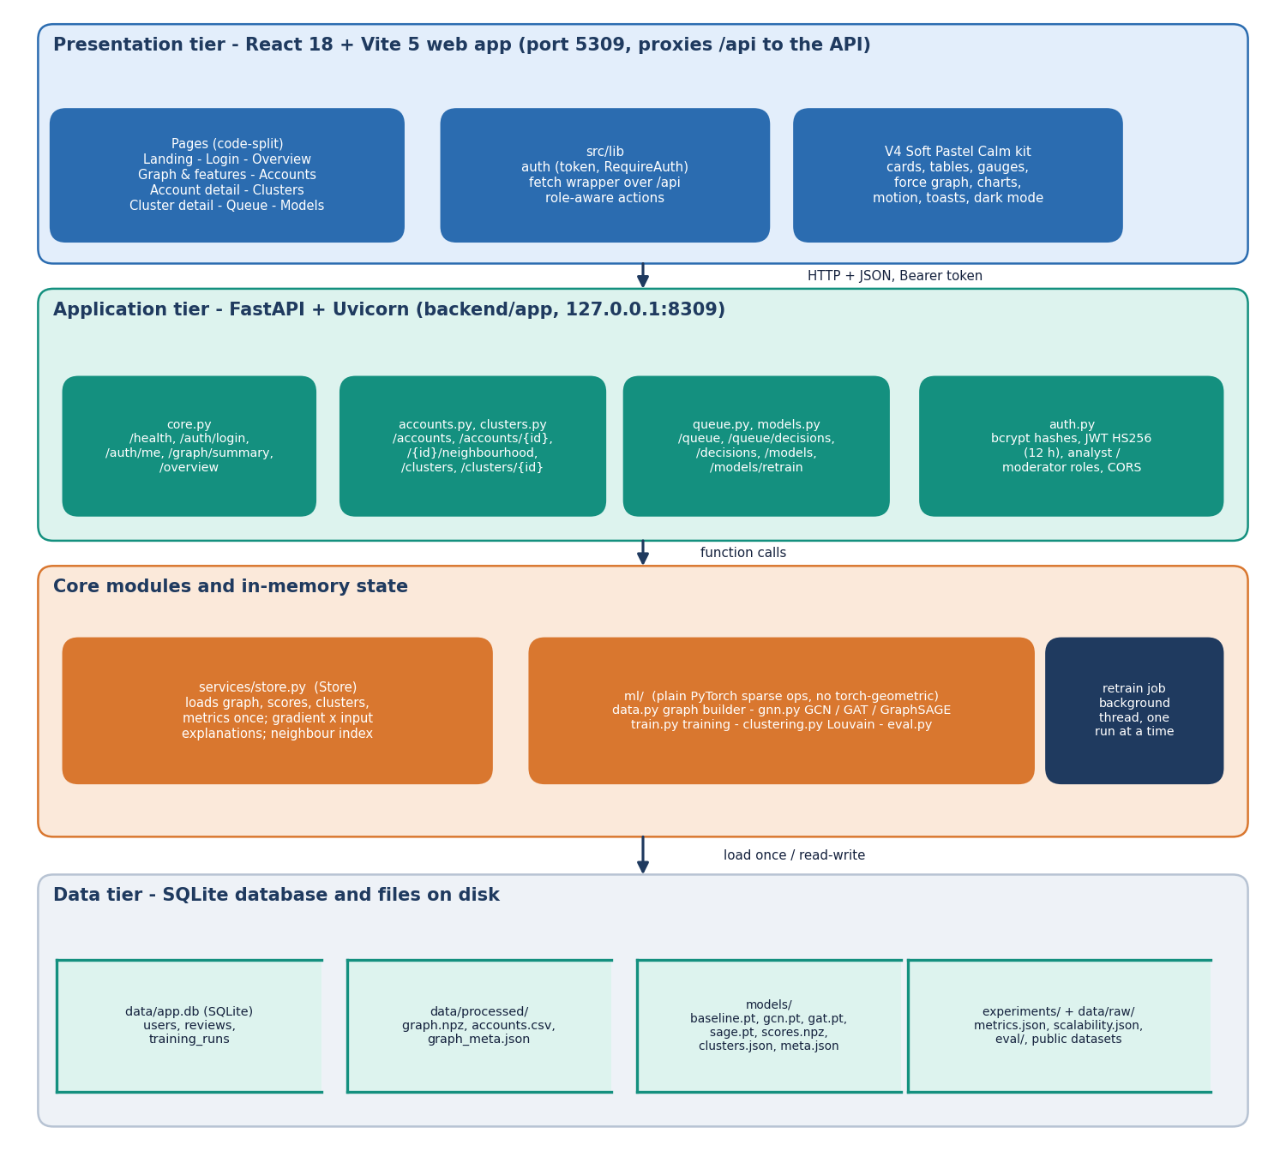
Figure 1: Architecture of BotGraph: data and ML pipeline, trained artefacts, FastAPI service with SQLite, and the React web application.
The system has four parts that meet at files and at one HTTP interface. The ML pipeline (ml/) builds the graph from the raw data and trains the models; it writes the graph (data/processed/), the trained weights, scores and clusters (models/) and the metrics (experiments/). The API (backend/app/, FastAPI on port 8309) loads those artefacts once when it starts and serves them under /api, and it keeps users, moderator decisions and retraining runs in SQLite. The web application (frontend/, React 18 and Vite on port 5309) proxies /api to the API. Retraining closes the loop: the API calls the same training code in a background thread, rewrites the artefacts and reloads its in-memory store.

1.2 High-Level Workflow
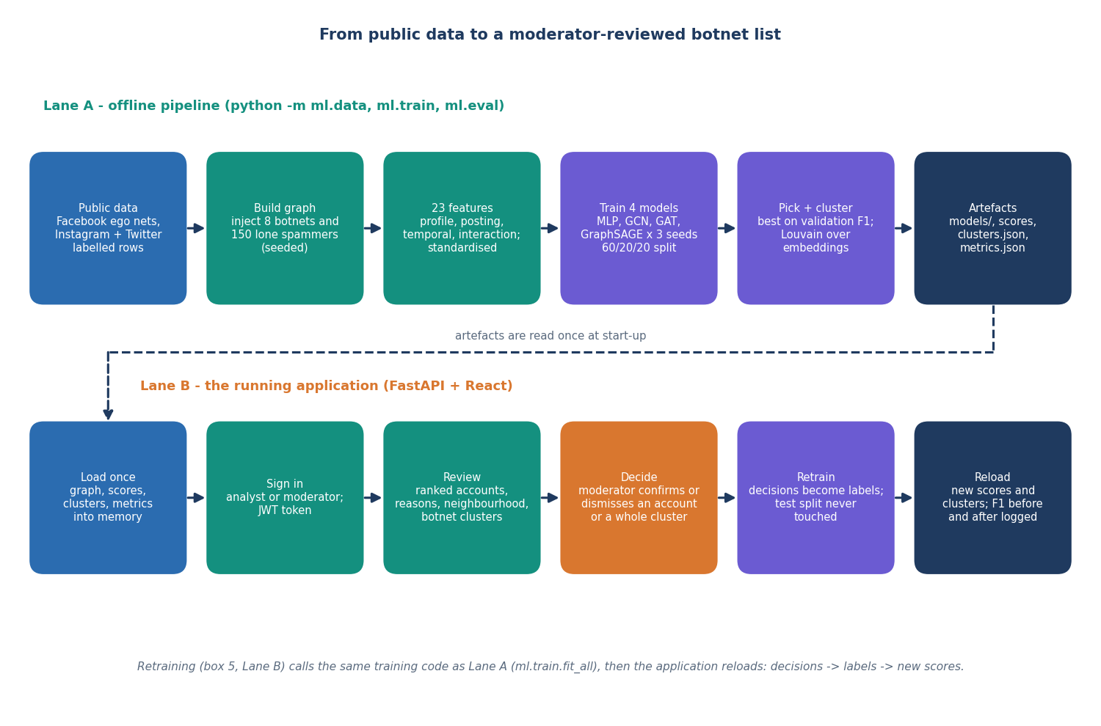
Figure 2: High-level workflow from raw data to moderator decisions and back into training.
The workflow runs in two directions. Forwards, raw datasets become a graph with 23 features per account; four models are trained on one stratified split; the best graph model on validation F1 is served; its embeddings feed Louvain clustering; and the API presents flagged accounts and clusters in a queue. Backwards, a moderator's confirm or dismiss decision is stored as a label, and the next retraining run adds those accounts to the training set, rewrites scores and clusters, and records F1 before and after.

1.3 Data Flow Diagrams

1.3.1 Level 0
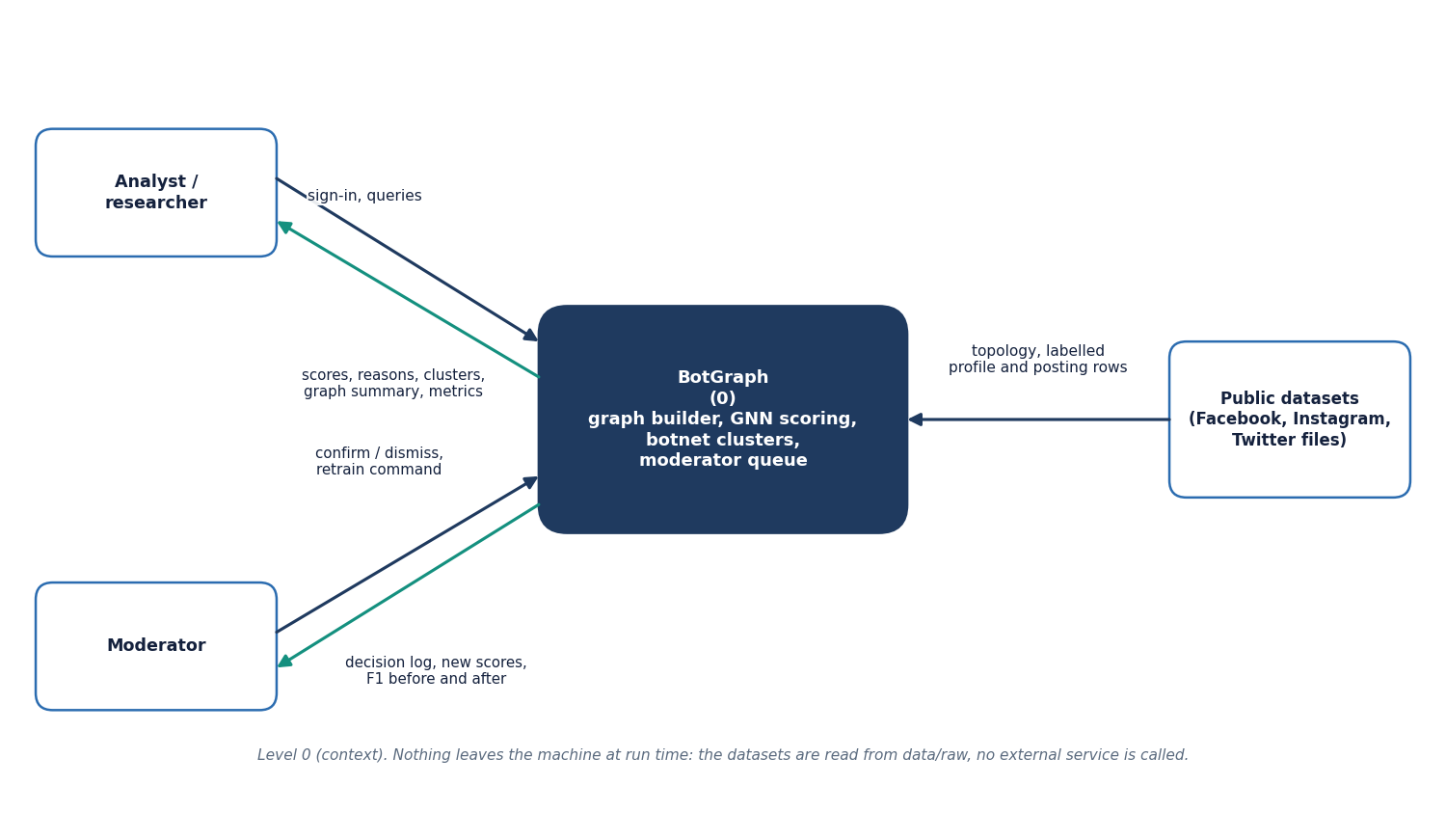
Figure 3: Data flow diagram, level 0: BotGraph as one process between its users and the data sources.
At level 0 the platform is one process. The analyst or researcher sends sign-in details and queries and receives scores, reasons, clusters, the graph summary and metrics; the moderator sends confirm or dismiss decisions and a retraining command and receives the decision log, new scores and F1 before and after. The three public data sets enter only when the graph is built or rebuilt; nothing leaves the machine at run time and no live platform feed exists.

1.3.2 Level 1
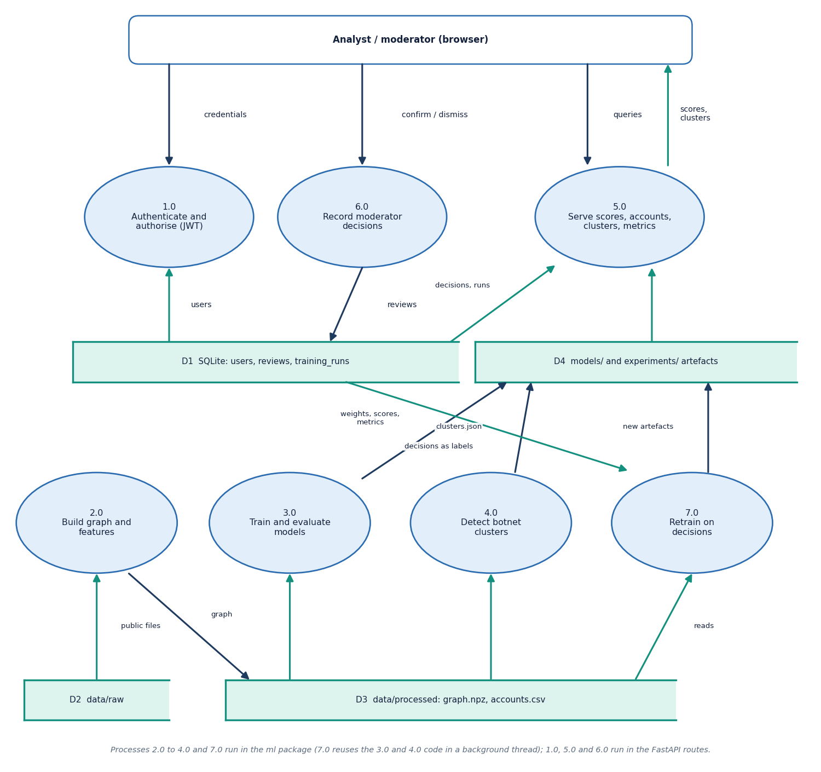
Figure 4: Data flow diagram, level 1: seven processes and four data stores.
Level 1 has seven processes and four data stores. Processes 2.0 (build the graph and features), 3.0 (train and evaluate the models) and 4.0 (detect botnet clusters) run in the ml package; they read the raw files (D2) and write the processed graph (D3) and the model and metric artefacts (D4). Process 1.0 authenticates requests against the users table, 5.0 serves scores, accounts, clusters and metrics from D3 and D4 and from the decisions in D1, and 6.0 records moderator decisions in D1. Process 7.0 retrains on those decisions: it reuses the training and clustering code in a background thread and writes new artefacts to D4. The review process is the only one that writes labels, and retraining is the only one that reads them back.

1.3.3 Level 2
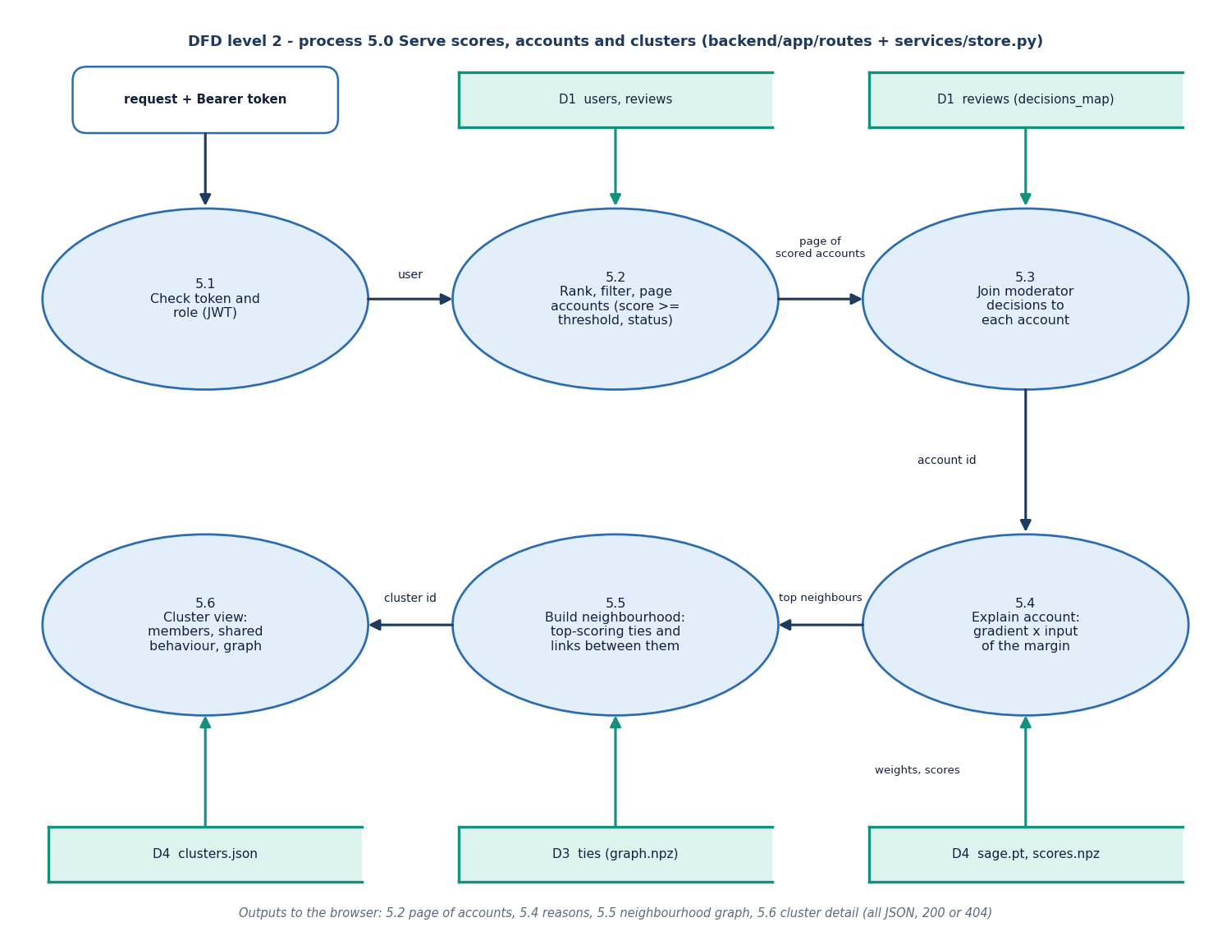
Figure 5: Data flow diagram, level 2: expansion of the serving process 5.0 into six steps.
Level 2 expands process 5.0, the serving process, into six steps. Step 5.1 checks the bearer token and the role. Step 5.2 ranks, filters and pages the accounts (score at or above the threshold, status, cluster, search) and 5.3 joins each account with the latest moderator decision, using the decision map built from the reviews. Step 5.4 explains one account by gradient times input through the served network, using the saved weights and scores; 5.5 builds the neighbourhood from the highest-scoring ties and the links between them; and 5.6 assembles the cluster view from clusters.json with members, shared behaviour and graph. Every output is JSON with a 200 or 404 status.

1.4 UML Design

1.4.1 Class Diagram
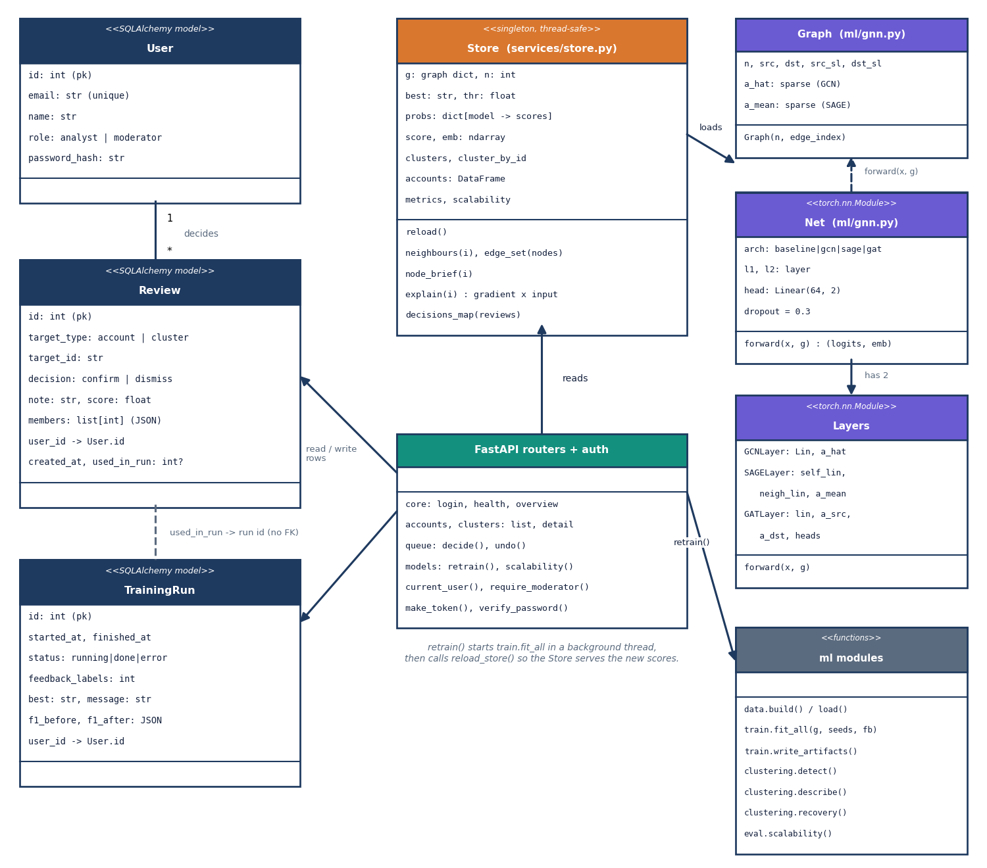
Figure 6: UML class diagram of the model classes, the Store, the database entities and the FastAPI routers.
The model side has a Graph class that precomputes the symmetric-normalised and the mean-aggregation adjacency, three layer classes (GCNLayer, SAGELayer, GATLayer) and Net, which stacks two layers and a linear head, or two dense layers for the baseline. On the service side, Store holds the graph, scores, clusters and metrics in memory and answers neighbourhood, explanation and decision queries; the three SQLAlchemy entities User, Review and TrainingRun persist state; and five routers expose the functions.

1.4.2 Sequence Diagram
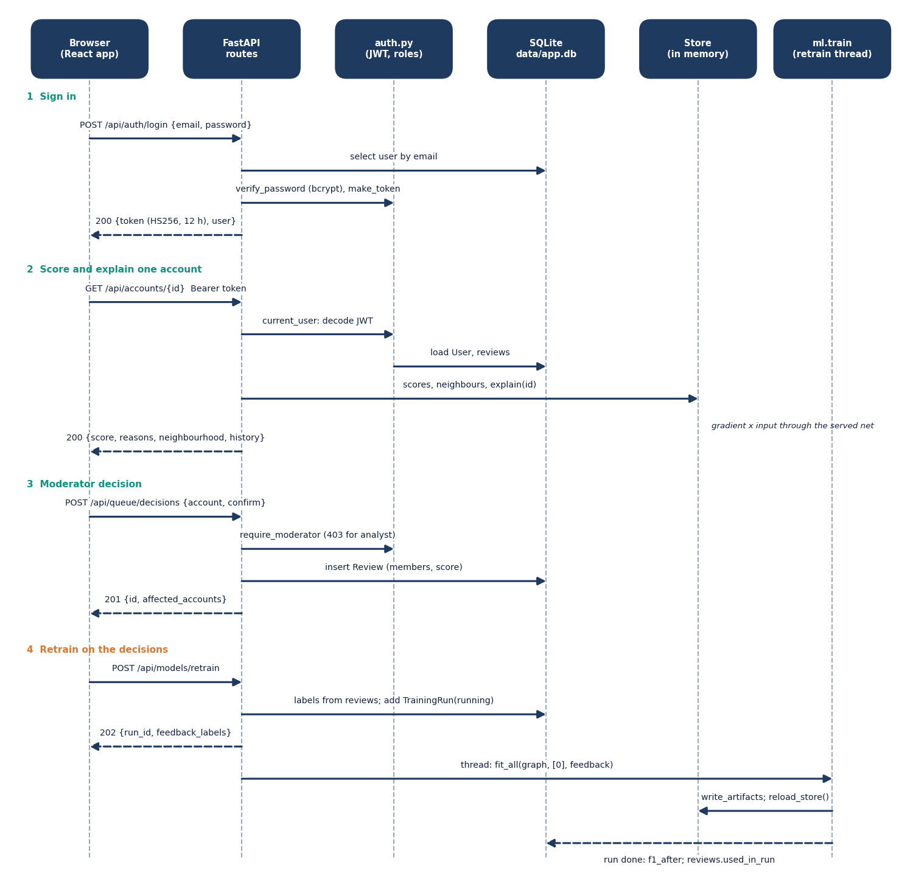
Figure 7: Sequence diagram of the main flow: sign in, score an account, record a decision, retrain.
The main flow starts with POST /api/auth/login, which checks the bcrypt hash and returns a signed token. GET /api/accounts/{id} then asks the Store for the score, the per-model scores, the gradient-times-input explanation and the neighbourhood summary. A moderator's POST /api/queue/decisions writes a Review row with the model score at the time and the affected account ids. POST /api/models/retrain creates a TrainingRun, starts a background thread that trains with the decisions as labels, reloads the Store and stamps the used decisions with the run id.

1.4.3 Use-Case Diagram
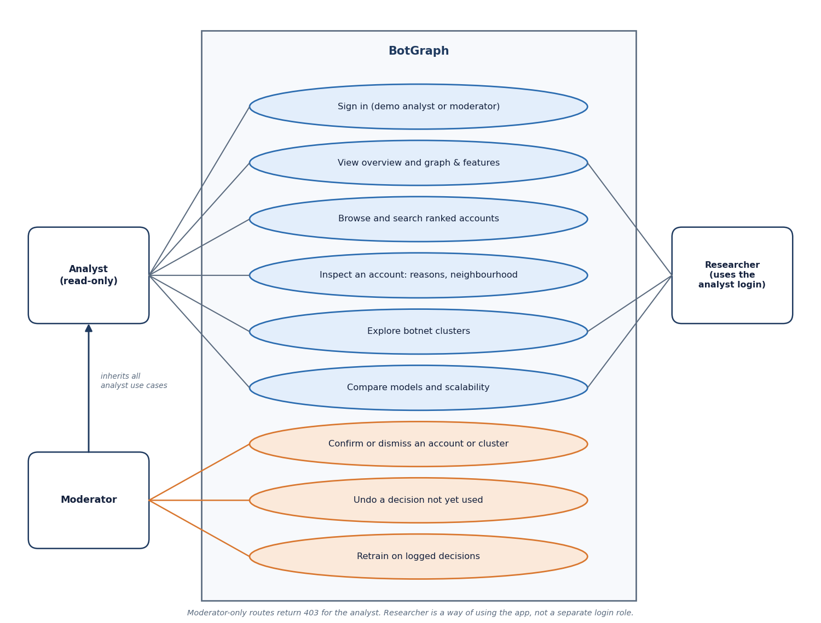
Figure 8: Use-case diagram for the analyst, the moderator and the researcher.
Three actors use the system. The analyst reads; the moderator reads and decides; the researcher reads the evaluation and scalability results. In the implementation the researcher is an analyst or moderator session, because the application has only two roles.

1.5 Data Design
Two stores are used. Structured, small, mutable data (users, decisions, retraining runs) live in SQLite. Large, read-only data (graph, scores, clusters, metrics) live in files that the API loads once. The split follows the access pattern: the files change only when a training run completes, the database changes with every moderator click.
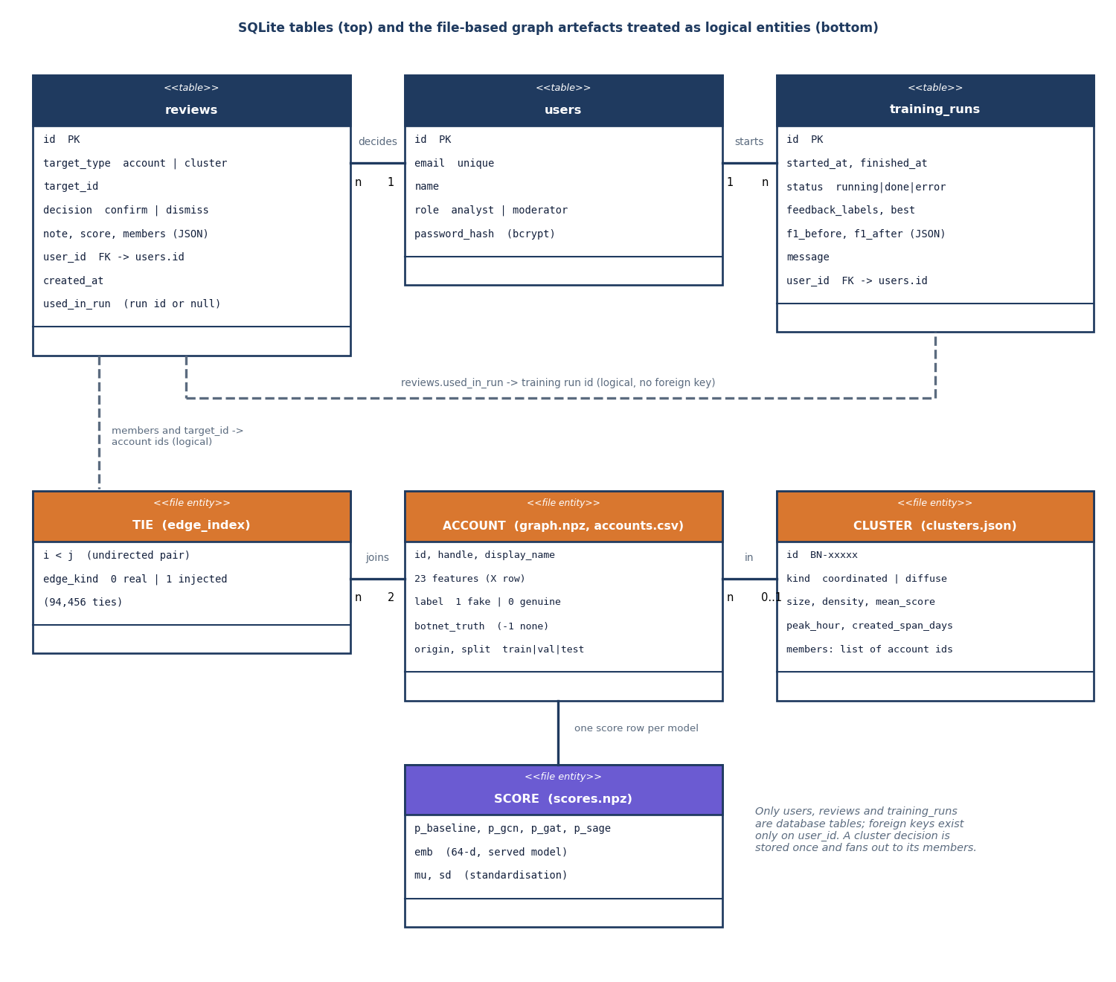
Figure 9: Entity-relationship diagram: the three database tables and the file-based graph, account and cluster entities.
Table 2: Table users
Column | Type | Notes
id | INTEGER, primary key
email | VARCHAR(160) | unique, indexed; matched in lower case
name | VARCHAR(120) | display name
role | VARCHAR(20) | analyst or moderator
password_hash | VARCHAR(80) | bcrypt hash; passwords longer than 72 bytes are truncated before hashing

Table 3: Table reviews (one moderator decision)
Column | Type | Notes
id | INTEGER, primary key
target_type | VARCHAR(10), indexed | account or cluster
target_id | VARCHAR(32), indexed | account id as text, or cluster id such as BN-00112
decision | VARCHAR(10) | confirm (fake) or dismiss (genuine)
note | TEXT | up to 500 characters from the API
score | FLOAT | model score at decision time (cluster mean for clusters)
members | JSON | ids of every account the decision applies to
user_id | INTEGER, foreign key to users.id | the moderator
created_at | DATETIME (UTC) | decision time
used_in_run | INTEGER, nullable | id of the training run that used it; set means the decision can no longer be undone

Table 4: Table training_runs
Column | Type | Notes
id | INTEGER, primary key
started_at, finished_at | DATETIME (UTC), finished_at nullable | run times
status | VARCHAR(12) | running, done or error
feedback_labels | INTEGER | number of moderator labels used
best | VARCHAR(12) | architecture served after the run
f1_before, f1_after | JSON | F1 per model before and after
message | TEXT | result or error text
user_id | INTEGER, nullable, foreign key to users.id | moderator who started the run

SQLite runs in write-ahead-logging mode with foreign keys on. The file-based artefacts are listed below.
Table 5: File artefacts
File | Content
data/processed/graph.npz | X (4,533 x 23 features), y (labels), edge_index (94,456 pairs), edge_kind, cluster (botnet truth), is_real, split, feature names
data/processed/accounts.csv | id, handle, display_name, label, origin, botnet_truth, split, followers, following, posts, bio_length, has_profile_pic, account_age_days, peak_hour, posts_per_day, interactions_per_week
data/processed/graph_meta.json | seed, real and injected counts, botnet sizes, lone spammers, camouflaged bots, suspicious genuine accounts
models/{baseline,gcn,gat,sage}.pt | state dictionaries of the seed-0 model of each architecture
models/scores.npz | feature mean and deviation, served embeddings, one probability vector per model
models/clusters.json | cluster id, kind, members and description fields
models/meta.json | training time, served architecture, threshold, split sizes, configuration
experiments/*.json | metrics per model and seed, ROC points, confusion matrices, cluster recovery, scalability

1.6 Algorithm Design

1.6.1 Graph and features
The graph builder takes the ten Facebook ego networks as the real topology (3,963 accounts, 88,156 ties), draws a profile row for every real account from the labelled Instagram set and a posting row from the Twitter set, and generates the timing and interaction features. It then injects eight botnets and 150 lone spammers with their ties. Inside a botnet every pair of accounts is tied with probability 0.28, plus a ring so that each botnet is connected; every bot also follows two to seven real accounts, chosen in proportion to the square root of their degree; some botnets tie to each other; each lone spammer ties to three to ten real accounts and to no other bot. Botnet members share a creation window and a peak posting hour, which makes those traits common to a cluster without making any single member stand out.
Camouflage keeps the task honest: 198 bots receive a genuine-looking profile and 231 genuine accounts a fake-looking one. Features are standardised with the mean and deviation of all nodes before training and the same values are stored for explanations.

1.6.2 Message passing and the classifier
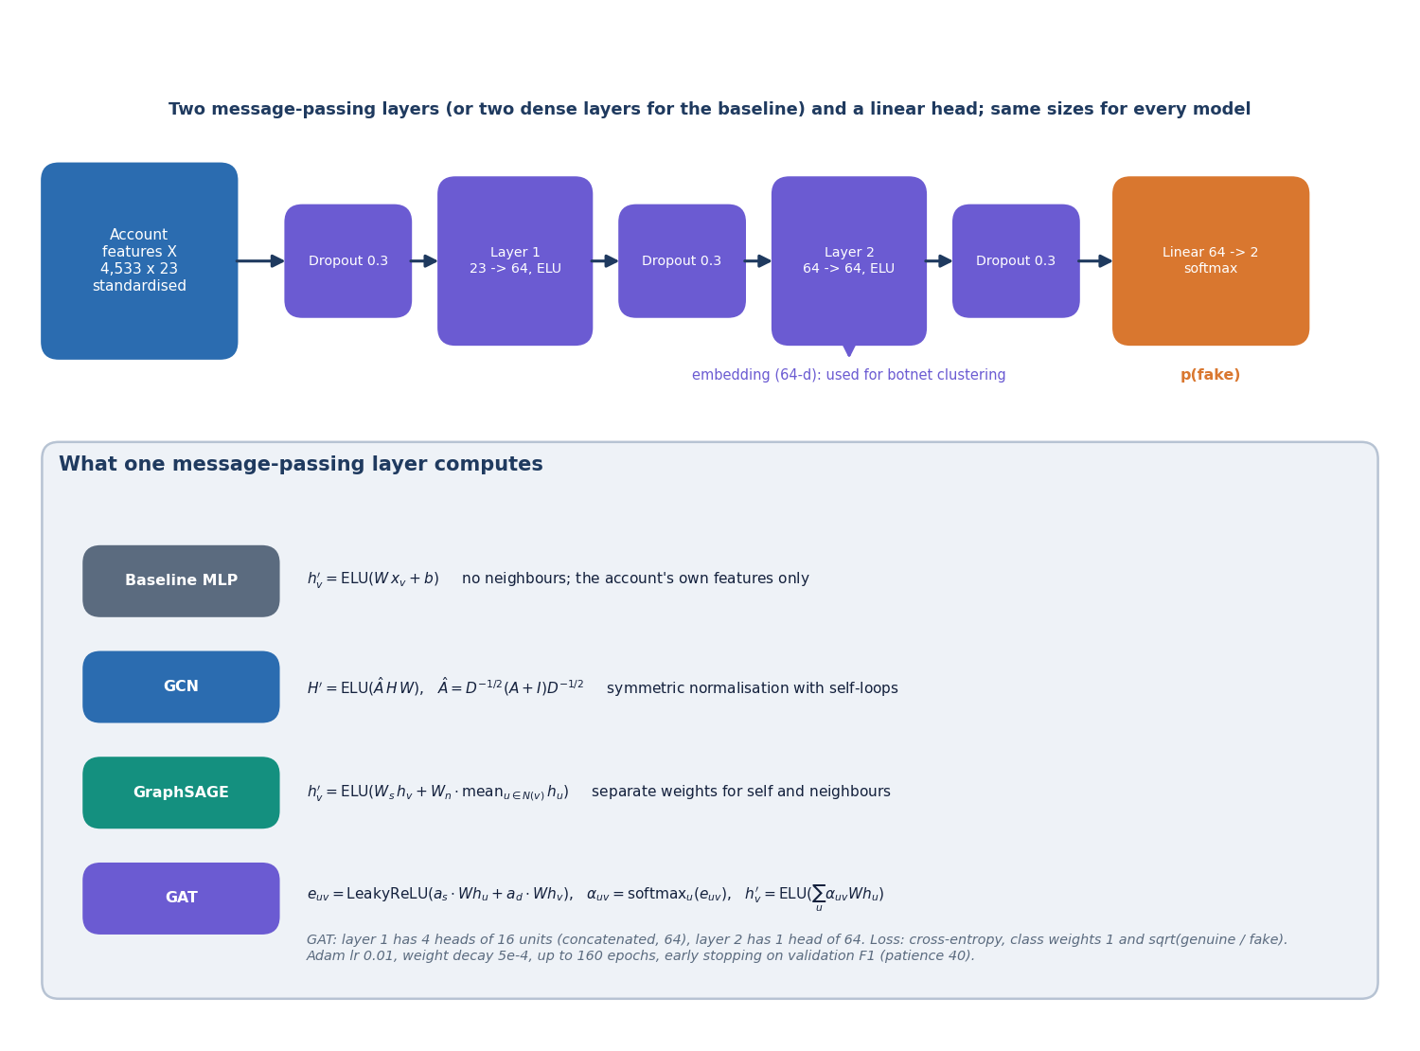
Figure 10: Model architecture: two message-passing layers, a linear head and the three layer types compared.
Every graph model has two message-passing layers of 64 units with ELU activation, dropout 0.3, and a linear head with two outputs. For node v with features x, the layers compute:
GCN: h_v = sum over u in N(v) + {v} of x_u W / sqrt(d_u d_v) (d counts the self-loop) (1)
GraphSAGE: h_v = W_self x_v + W_neigh * mean over u in N(v) of x_u (2)
GAT: e_uv = LeakyReLU(a_src . W x_u + a_dst . W x_v), alpha_uv = softmax over u of e_uv, h_v = sum over u of alpha_uv W x_u (4 heads of 16 units, then 1 head of 64) (3)
The baseline replaces each message-passing layer with a dense layer, so it reads only the account's own features. Training uses Adam (learning rate 0.01, weight decay 5e-4), a cross-entropy loss with class weights 1 for genuine and the square root of the imbalance for fake, up to 160 epochs, and keeps the epoch with the best validation F1 (patience 40). After training, the decision threshold is chosen on the validation set from 33 values between 0.1 and 0.9 to maximise F1. The architecture with the best validation F1 among the graph models is served.
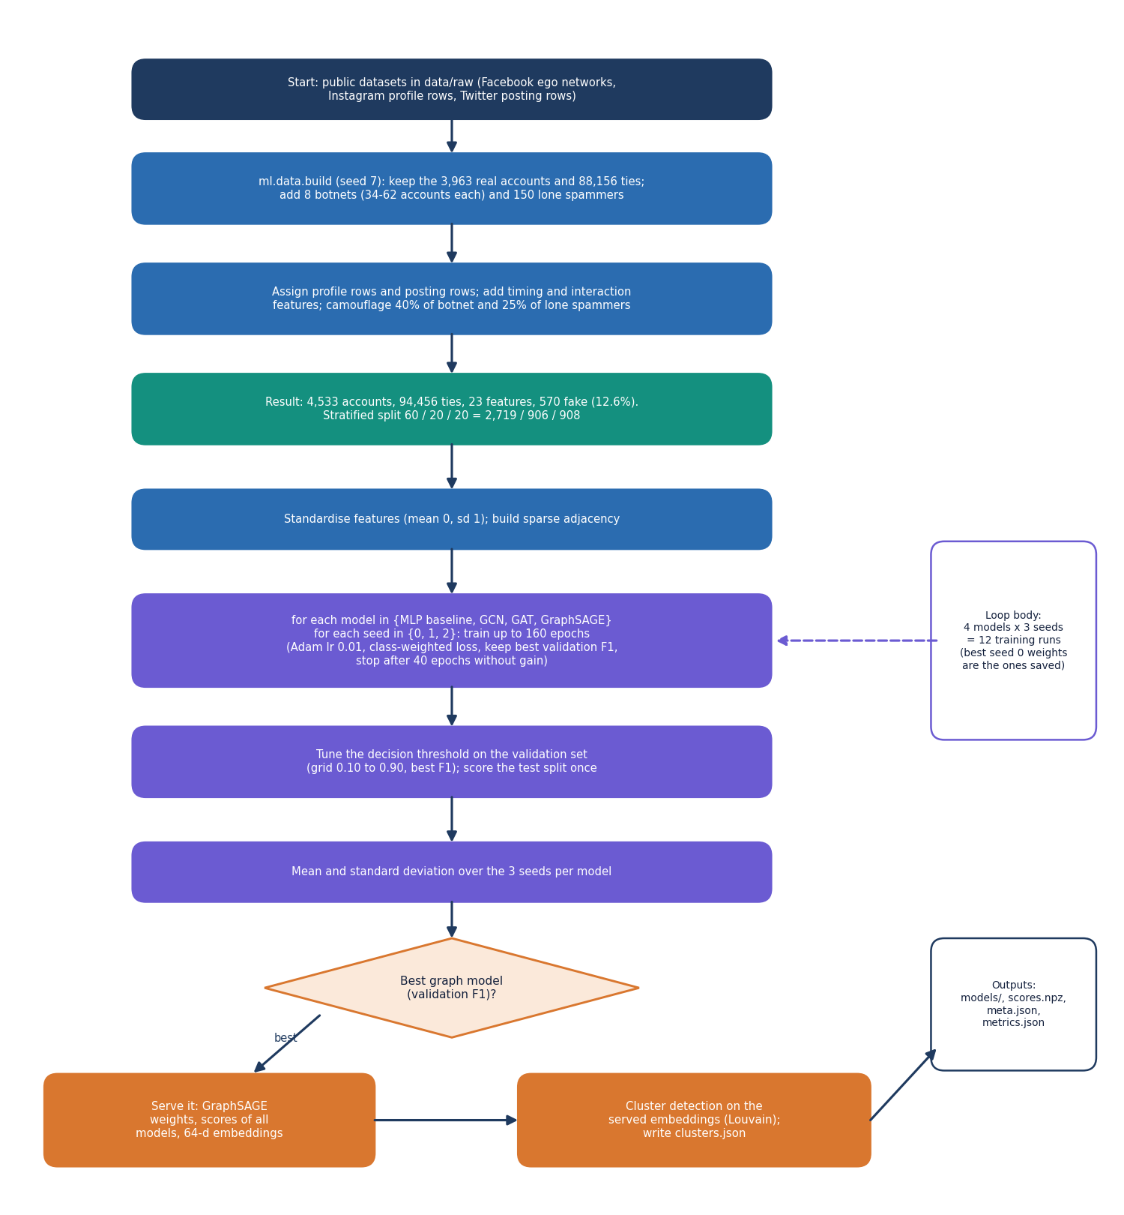
Figure 11: Flowchart of the training pipeline from graph to served model.

1.6.3 Botnet clustering
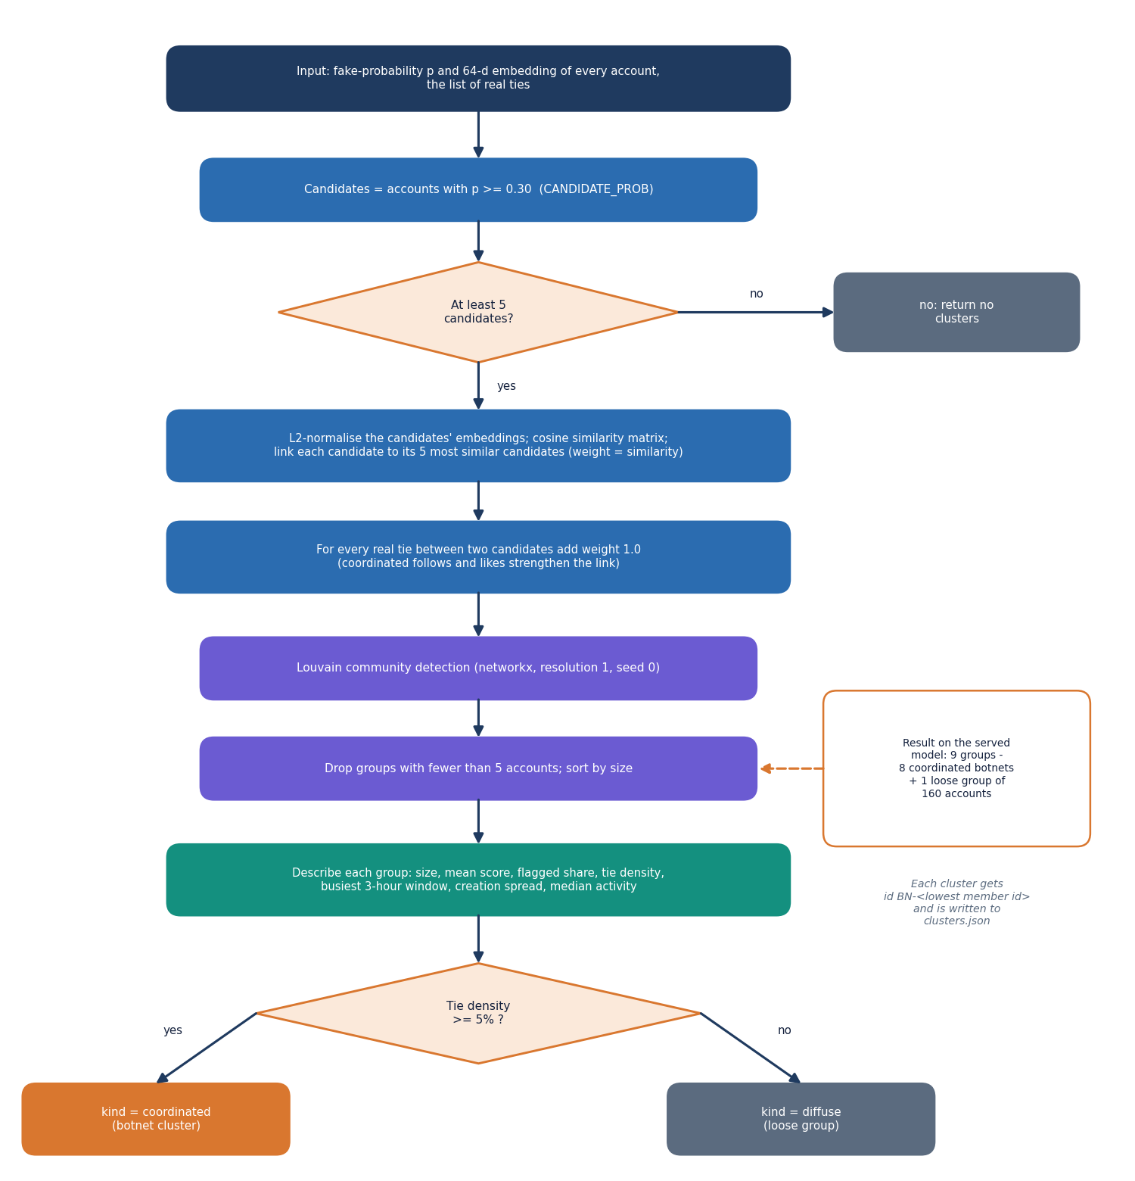
Figure 12: Flowchart of botnet cluster detection with Louvain over embeddings and real ties.
Clustering works on the accounts whose probability is at least 0.30. Each candidate is linked to its five most cosine-similar candidates in embedding space (weight equal to the similarity) and every real tie between two candidates adds weight 1.0. Louvain community detection (networkx, resolution 1.0, seed 0) groups the weighted graph and groups under five accounts are dropped. Each group is described by size, mean score, share flagged, internal ties, tie density (internal ties divided by n(n-1)/2), the busiest 3-hour window and the share of members in it, the spread of creation dates, and median posting rate, interactions and followers. A group is labelled coordinated when its density is at least 5% and diffuse otherwise.

1.6.4 Explanations
The reason shown for an account is the gradient of the model's fake-versus-genuine margin with respect to the input features, multiplied by the input values. For the account's own seven largest contributions the application draws a bar; one further number reports how much the other accounts' features contribute through message passing. This is a first-order approximation and the interface says so.

1.7 Module Design
Table 6: Modules and responsibilities
File | Responsibility | Lines
ml/config.py | paths, seed, model list, training and clustering constants | 39
ml/data.py | load the three sources, inject botnets, build 23 features, split, save and summarise the graph | 345
ml/gnn.py | sparse Graph, GCN, SAGE and GAT layers, Net, class weights, threshold search, metrics, training loop | 188
ml/train.py | train every model for every seed, summarise, write weights, scores, clusters and metrics; also used for retraining with feedback labels | 138
ml/clustering.py | candidate selection, similarity graph, Louvain, cluster description, recovery against truth | 100
ml/eval.py | scalability sweep over 1, 2, 4 and 8 disjoint copies of the graph; evaluation summary | 90
backend/app/main.py, settings.py | application, CORS, start-up (database, demo users, Store); environment settings | 31, 31
backend/app/auth.py | bcrypt, JWT creation and checking, current_user, require_moderator, demo users | 70
backend/app/db.py | SQLAlchemy engine, User, Review, TrainingRun, session dependency | 87
backend/app/services/store.py | in-memory graph, scores, clusters, adjacency, neighbour statistics, explanations, decision map | 181
backend/app/routes/core.py | health, login, current user, graph summary, overview | 87
backend/app/routes/accounts.py | ranked list with filters, account detail, neighbourhood | 122
backend/app/routes/clusters.py | cluster list and detail with members, graph, reach and headline | 73
backend/app/routes/queue.py | queue, decisions, undo, decision log | 125
backend/app/routes/models.py | model comparison, scalability, retraining job and its status | 124
frontend/src/pages/ | Landing, Login, Overview, GraphData, Accounts, AccountDetail, Clusters, ClusterDetail, Queue, Models, NotFound | 11 files
frontend/src/components/ | UI kit (ui), motion, charts (Recharts), graph/ForceGraph, app (decision panel, retrain card), reactbits/Blobs | 6 folders
scripts/ | smoke_test.py, capture_screens.py, ui_checks.py, download_data.py, run_extra_experiments.py | 5 files

1.8 API Design
The API is a JSON interface under /api. Every route except /api/health and /api/auth/login requires Authorization: Bearer <token>; moderator routes also check the role.
Table 7: Endpoints
Method and path | Access | Purpose
GET /api/health | public | status, account and tie counts, served model, flagged and botnet counts, best and baseline F1
POST /api/auth/login | public | e-mail and password to token and user
GET /api/auth/me | signed in | current user
GET /api/graph/summary | signed in | counts (real and injected), class balance, split, 23 feature summaries, degree histogram, provenance
GET /api/overview | signed in | KPIs, score histogram, model F1, top accounts and clusters, recent decisions
GET /api/accounts | signed in | ranked page; query, status, flagged only, cluster, sort, order, page, page size (at most 100)
GET /api/accounts/{id} | signed in | score, per-model scores, explanation, neighbourhood summary, profile, decision history
GET /api/accounts/{id}/neighbourhood | signed in | nodes and links, highest-scoring neighbours first (5 to 120)
GET /api/clusters | signed in | all clusters with status
GET /api/clusters/{id} | signed in | members, graph, shared behaviour, reach, headline
GET /api/queue | signed in | pending or decided accounts or clusters with summary counts
POST /api/queue/decisions | moderator | record confirm or dismiss for an account or cluster (201)
DELETE /api/queue/decisions/{id} | moderator | undo a decision not yet used in training
GET /api/decisions | signed in | decision log
GET /api/models | signed in | per-model metrics, ROC, confusion, cluster recovery, runs, retraining state
GET /api/models/scalability | signed in | training and inference time against graph size
POST /api/models/retrain | moderator | start a retraining run on the logged decisions (202)
GET /api/models/retrain/status | signed in | state, progress, message

Table 8: Error responses
Status | When
401 | no token, an invalid or expired token, or a wrong e-mail and password
403 | an analyst calls a moderator route
404 | unknown account or cluster id (a cluster id can change after retraining), no evaluation file
409 | undo of a used decision; retraining with no decisions or while a run is in progress
422 | request validation failed (for example a non-numeric account id or a decision other than confirm or dismiss)

1.9 User Interface Design
The web application uses the V4 Soft Pastel Calm design kit: warm off-white surfaces, rounded cards, six pastel accent colours (lavender, mint, peach, sky, rose, butter) read from CSS variables, light and dark themes, and restrained motion. Charts take their colours from the same variables, so they follow the theme. Every route is code-split and loaded on demand.
Table 9: Screen map
Route | Screen | What it answers
/ | Landing | what BotGraph is; live counts from the health route
/login | Sign in | demonstration accounts with one-click fill
/app | Overview | how many accounts, flags, botnets, items waiting; does the graph help
/app/graph | Graph and features | what is in the graph, which part is real, which features exist
/app/accounts | Accounts | who is flagged; search, filters and paging
/app/accounts/:id | Account detail | why this score; who the neighbours are; decide
/app/clusters, /app/clusters/:id | Botnet clusters | which groups exist; their graph, members and shared behaviour
/app/queue | Moderator queue | what is waiting; decision log; retrain
/app/models | Models and scale | which model is best; how cost grows

Every screen has a loading skeleton, an empty state with an action, an error state with a retry and visible success feedback through toasts. Keyboard focus rings, dialogs that close with Escape, a persisted theme toggle and respect for reduced-motion settings are part of the kit; they were checked when the interface was built and recorded in docs/FRONTEND_PLAN.md, and were not repeated in the documentation run. Four of the screens are shown below; the others appear in Chapter 8 and Appendix C.
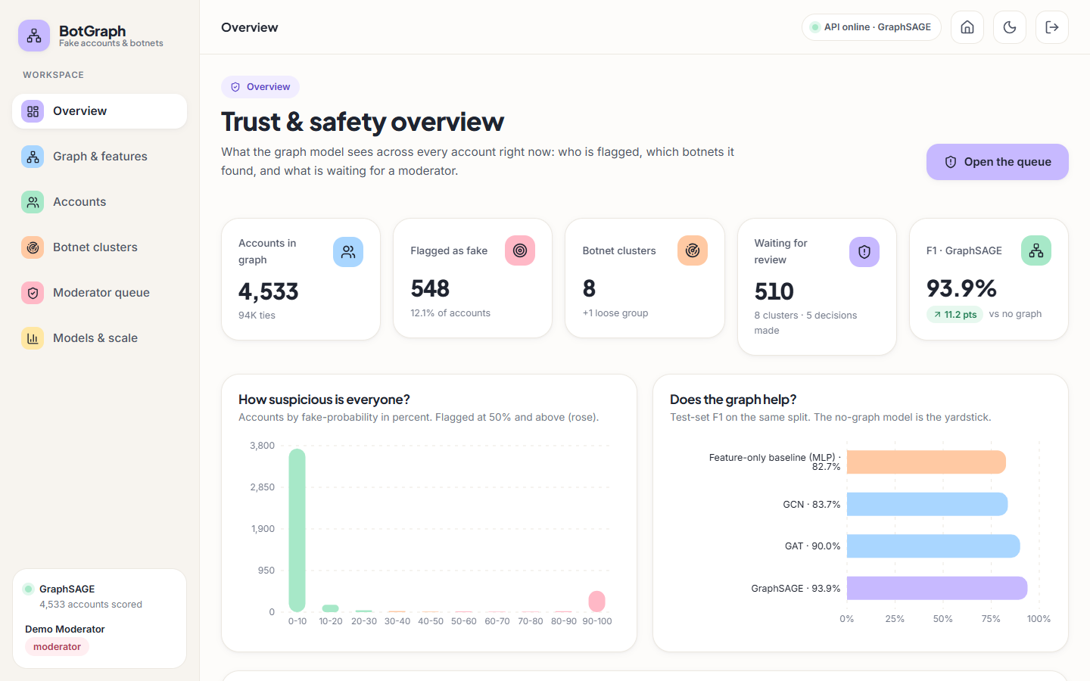
Figure 13: Overview screen: key counts, the score histogram and the model comparison.
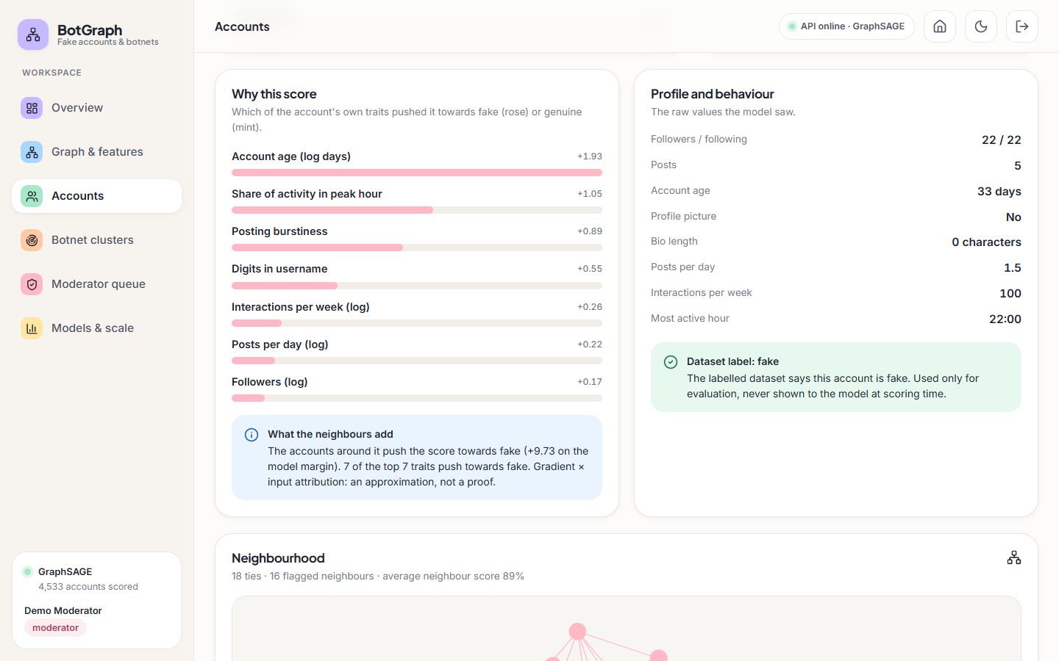
Figure 14: Account detail: the traits behind the score, the profile values and the neighbourhood graph.
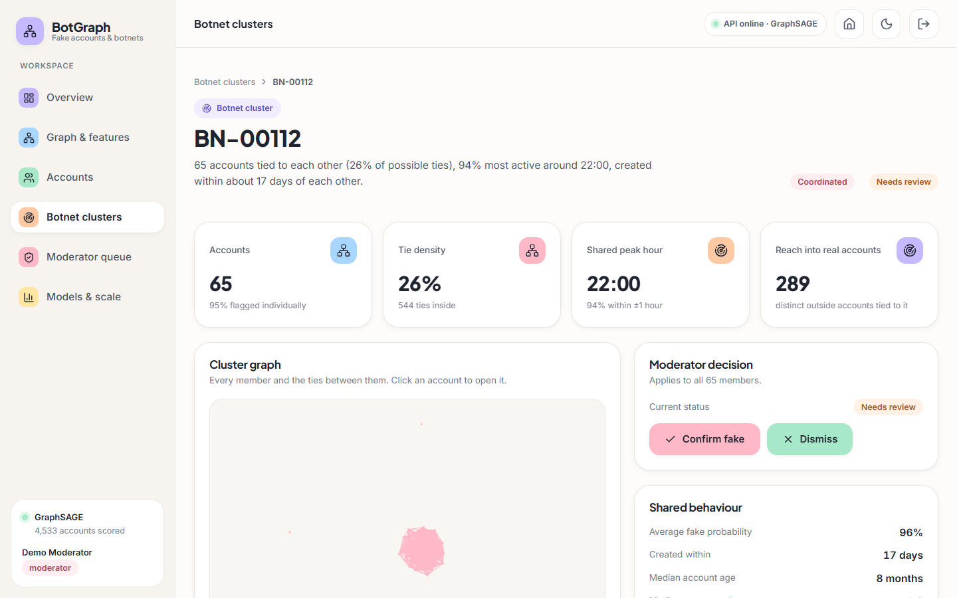
Figure 15: Cluster detail: size, tie density, shared peak hour, reach, and the moderator decision.
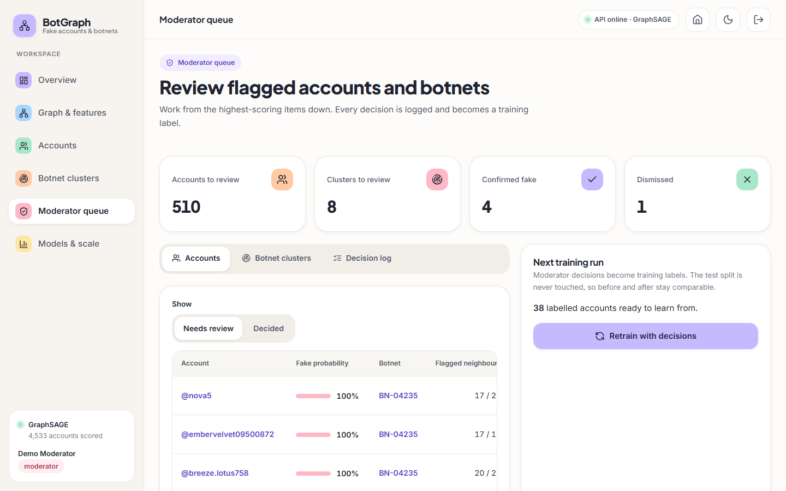
Figure 16: Moderator queue: items waiting, confirmed and dismissed counts, and the retraining card.

1.10 Key Design Decisions
1. Plain PyTorch instead of a graph library. The three layers are about 50 lines on sparse tensors; this removes a dependency that is a frequent build failure on Windows and keeps every operation visible.
2. One stratified split, three seeds. All models see the same accounts, so differences are due to the model; three seeds expose the variance.
3. Threshold from validation. The decision threshold is tuned on the validation split and never on the test split.
4. Class weight by the square root of the imbalance. The square root softens the correction for the 12.6% fake share; a full inverse weight was not tried.
5. Louvain over embeddings and real ties. Embedding similarity finds accounts that behave alike; real ties keep a cluster anchored in the graph.
6. Artefacts loaded once. The Store holds everything in memory, which is why read routes answer in milliseconds.
7. SQLite for decisions only. Mutable state is small; large read-only data stay in files.
8. Test split protected. Feedback labels only move accounts into training.

1.11 Security and Error-Handling Design
• Passwords are stored as bcrypt hashes. Tokens are HS256 JWTs that expire after 12 hours; a placeholder secret is replaced by a development secret and should be replaced for any real deployment.
• Role checks run on the server in the require_moderator dependency; hiding a button in the interface is not relied on.
• CORS allows only the web application's own origin (localhost and 127.0.0.1 on port 5309).
• Request bodies are validated by Pydantic (target type, decision, note length) and query parameters by bounds (page size, neighbour limit).
• Errors are returned as plain sentences the interface can show, such as Please sign in to continue or That decision was already used to train a model run and cannot be undone.
• A failing retraining run is recorded with status error and the first 400 characters of the message, and the served model is left unchanged.

2. IMPLEMENTATION

2.1 Application architecture
The application has three tiers. The ML package (ml/) is run from the command line and writes files: data/processed/graph.npz and accounts.csv, models/*.pt, scores.npz, clusters.json, meta.json, and experiments/*.json. The API (backend/app/) is a FastAPI application served by Uvicorn on port 8309. At start-up it creates the SQLite tables, seeds the two demo users and loads the graph, scores, embeddings and clusters into one in-memory Store. The web app (frontend/) is a React 18 single-page application built with Vite on port 5309 that proxies /api to the API.
Table 10: Backend modules
Module | Responsibility
main.py | Creates the app, lifespan hook (tables, demo users, store), CORS, registers five routers
settings.py | Reads .env.example then .env; ports, database URL, JWT secret and lifetime
db.py | SQLAlchemy 2 models User, Review, TrainingRun; SQLite with WAL journal and foreign keys on
auth.py | bcrypt password hashing, JWT creation and checking, current_user and require_moderator dependencies, demo users
services/store.py | In-memory view of artefacts: graph, scores, clusters, neighbour index, gradient × input explanation (cached)
routes/core.py | Health, login, current user, graph summary, overview
routes/accounts.py | Ranked account list with filters, account detail, neighbourhood graph
routes/clusters.py | Cluster list and cluster detail
routes/queue.py | Moderator queue, decisions, undo, decision log
routes/models.py | Model comparison, scalability, retraining job and its status

The web app has eleven pages: landing, sign-in, overview, graph and features, accounts, account detail, botnet clusters, cluster detail, moderator queue, models and scale, and a not-found page. Every data page shows a loading skeleton, an empty state with an action, an error state with a retry, and a toast after every action. The layout works at 360, 768 and 1440 px in light and dark themes.

2.2 API design
All routes sit under /api and exchange JSON. Every route except GET /api/health and POST /api/auth/login needs an Authorization: Bearer <token> header. Routes that change data or start training additionally need the moderator role.
Table 11: API endpoints
Method | Path | Role | Purpose
GET | /api/health | public | Status, account and tie counts, served model, flagged count, botnet count, best and baseline F1
POST | /api/auth/login | public | Email and password in, token and user out
GET | /api/auth/me | any | The signed-in user
GET | /api/graph/summary | any | Node and tie counts (real and injected), class balance, split, feature summaries, degree histogram, dataset provenance
GET | /api/overview | any | KPIs, score histogram, model F1 list, top accounts, top clusters, recent decisions
GET | /api/accounts | any | Ranked accounts with search, status, cluster and flag filters, sorting and paging
GET | /api/accounts/{id} | any | Score, per-model scores, top contributing features, neighbourhood summary, profile, decision history
GET | /api/accounts/{id}/neighbourhood | any | Nodes and links of the account's neighbourhood for the graph view
GET | /api/clusters | any | Detected clusters with size, density, shared hour and status
GET | /api/clusters/{id} | any | Members, shared behaviour, reach, graph and headline of one cluster
GET | /api/queue | any | Pending or decided accounts and clusters, with summary counts
POST | /api/queue/decisions | moderator | Confirm or dismiss an account or cluster (201)
DELETE | /api/queue/decisions/{id} | moderator | Undo a decision not yet used in training
GET | /api/decisions | any | The decision log
GET | /api/models | any | Per-architecture metrics, ROC points, confusion matrices, cluster recovery, retraining runs
GET | /api/models/scalability | any | Training and inference time as the graph grows
POST | /api/models/retrain | moderator | Start a retraining run on the logged decisions (202)
GET | /api/models/retrain/status | any | State, progress and message of the running job

Request bodies are validated with Pydantic models: a decision must name a target_type (account or cluster), a target_id, a decision (confirm or dismiss) and a note of at most 500 characters; list endpoints bound page (at least 1) and page_size (at most 100). FastAPI also serves interactive documentation of every route at /docs.
Measured on 127.0.0.1 with a warm server, the read endpoints answered in a median of 3.0 to 16.0 ms (95th percentile at most 28.4 ms); sign-in took a median of 233 ms because bcrypt is deliberately slow, and the API needed 5.1 s from launch to its first healthy answer. These figures come from one shared laptop-class machine and are upper bounds (Chapter 7).

2.3 Security and error handling
• Authentication. Passwords are hashed with bcrypt (the password is cut at bcrypt's 72-byte limit before hashing). A successful login returns an HS256 JSON Web Token that carries the user id, the role and an expiry 12 hours ahead.
• Authorisation. current_user rejects a missing header, a malformed or expired token and a token for a user that no longer exists with 401 and a plain-language message. require_moderator returns 403 for analysts on decision, undo and retrain routes. The smoke test checks that an anonymous request gets 401 and that an analyst cannot record a decision.
• Wrong credentials. An unknown email or a wrong password gives the same 401 message, so the response does not reveal which accounts exist.
• Input validation. Unknown account ids give 404, non-numeric account ids give 422, unknown cluster ids give 404 with a hint that clusters change after retraining, paging bounds are enforced by the framework, and notes longer than 500 characters are refused.
• State conflicts. Undoing a decision already used in training gives 409; starting a second retraining run while one is running gives 409; retraining with no decisions gives 409 with an instruction.
• Retraining failures. The job runs in a background thread; an exception is stored on the training_runs row with status error and shown in the app, and the served model is left unchanged.
• Cross-origin requests. CORS allows only the web app's own origins (localhost and 127.0.0.1 on port 5309).
• Secrets. The JWT secret comes from .env; if it is missing or still the placeholder, a fixed development secret is used, which is acceptable for a local demo only. .env is excluded from version control and nothing is sent to any outside service.
These measures suit a local demonstration. They do not amount to a production security design: there are two seeded accounts with a shared demo password, no password reset, no multi-factor sign-in, no rate limiting, no token revocation and no audit trail beyond the decision log, and TLS is not configured (Chapter 10).

2.4 Installation and execution
BotGraph runs on one Windows computer with Python 3.11 or newer and Node.js (LTS). About 3 GB of disk space is needed, mostly for PyTorch, and an internet connection for the first setup.
1. Open the 8.ProjectCode folder and double-click run.bat. On the first run it calls setup.bat, which creates .venv, installs the Python packages from backend/requirements.txt and the web packages with npm install, and copies .env.example to .env.
2. run.bat starts the API (uvicorn backend.app.main:app on 127.0.0.1:8309) and the web app (npm run dev on 5309) in two minimised windows, waits up to about 90 seconds for /api/health to answer, and opens http://localhost:5309.
3. Sign in with moderator@botgraph.app (can decide and retrain) or analyst@botgraph.app (read-only); the password is Demo@1234 and the sign-in page fills it with one click.
4. Close the two windows to stop the application.
The trained models, scores and clusters are included, so nothing needs training before the first start. The pipeline can be re-run with python -m ml.data (rebuild the graph), python -m ml.train (train all models, a few minutes on CPU) and python -m ml.eval (scalability sweep), and python scripts/smoke_test.py runs the end-to-end test on a scratch database. Appendix B gives the full guide and troubleshooting.

3. KEY CODE WALK-THROUGHS
This section walks through the code that carries the design. The listings are copied from the repository at the state in which the results were measured.

3.1 The graph object and the GraphSAGE layer
class Graph:
"""Everything the layers need, built once from an undirected edge list (i < j)."""

def __init__(self, n: int, edge_index: np.ndarray):
src = np.concatenate([edge_index[:, 0], edge_index[:, 1]])
dst = np.concatenate([edge_index[:, 1], edge_index[:, 0]])
self.n = n
self.src = torch.as_tensor(src, dtype=torch.long)
self.dst = torch.as_tensor(dst, dtype=torch.long)
loops = torch.arange(n)
self.src_sl = torch.cat([self.src, loops])
self.dst_sl = torch.cat([self.dst, loops])
deg = torch.bincount(self.dst_sl, minlength=n).float()
w = (deg[self.src_sl] * deg[self.dst_sl]).rsqrt()
self.a_hat = torch.sparse_coo_tensor(torch.stack([self.dst_sl, self.src_sl]), w, (n, n)).coalesce()
deg0 = torch.bincount(self.dst, minlength=n).clamp(min=1).float()
self.a_mean = torch.sparse_coo_tensor(torch.stack([self.dst, self.src]), 1.0 / deg0[self.dst], (n, n)).coalesce()

class SAGELayer(nn.Module):
def __init__(self, i, o):
super().__init__()
self.self_lin = nn.Linear(i, o)
self.neigh_lin = nn.Linear(i, o, bias=False)

def forward(self, x, g: Graph):
return self.self_lin(x) + self.neigh_lin(torch.sparse.mm(g.a_mean, x))

Graph is built once from the undirected tie list: both directions of every tie are stacked, self-loops are added for GCN and GAT, and two sparse matrices are prepared. a_hat holds the symmetric normalisation D̃^(-1/2) Ã D̃^(-1/2) used by GCN, and a_mean divides each row by the number of neighbours, so that a sparse product with a feature matrix returns the mean of each account's neighbours. SAGELayer then adds two linear maps: one for the account's own features and one, without a bias, for that neighbour mean. The separate weights are what distinguishes GraphSAGE from GCN here, and the two-line forward is the whole of the layer; no external graph library is involved.

3.2 The class weights
def class_weights(y_train: np.ndarray) -> torch.Tensor:
pos = max(1, int(y_train.sum()))
neg = max(1, len(y_train) - pos)
return torch.tensor([1.0, float(np.sqrt(neg / pos))], dtype=torch.float32)

The loss gives genuine accounts weight 1 and fake accounts the square root of the ratio of genuine to fake accounts in the training labels. With about one fake account in eight the weight is about 2.6, a middle course between ignoring the imbalance and weighting by the full ratio, which would favour recall at the cost of many false alarms. The counts are taken from the labels the loss will actually see, so after moderator feedback the weight changes with them.

3.3 Botnet clustering
def detect(emb: np.ndarray, prob: np.ndarray, edge_index: np.ndarray, seed: int = 0) -> list[np.ndarray]:
cand = np.where(prob >= C.CANDIDATE_PROB)[0]
if len(cand) < C.MIN_CLUSTER:
return []
e = emb[cand]
e = e / np.maximum(np.linalg.norm(e, axis=1, keepdims=True), 1e-9)
sim = e @ e.T
np.fill_diagonal(sim, -1)
k = min(C.KNN, len(cand) - 1)
nn_idx = np.argpartition(-sim, k - 1, axis=1)[:, :k]
G = nx.Graph()
G.add_nodes_from(cand.tolist())
for a in range(len(cand)):
for b in nn_idx[a]:
w = max(float(sim[a, b]), 0.0)
if w > 0:
G.add_edge(int(cand[a]), int(cand[b]), weight=w)
cand_set = set(cand.tolist())
for u, v in edge_index:
if int(u) in cand_set and int(v) in cand_set:
G.add_edge(int(u), int(v), weight=G.get_edge_data(int(u), int(v), {"weight": 0.0})["weight"] + 1.0)
comms = nx.community.louvain_communities(G, weight="weight", resolution=1.0, seed=seed)
out = [np.array(sorted(c)) for c in comms if len(c) >= C.MIN_CLUSTER]
out.sort(key=lambda c: -len(c))
return out

detect keeps only accounts with a probability of at least 0.30, normalises their embeddings to unit length so that a matrix product gives cosine similarities, and takes each candidate's five most similar candidates with argpartition. Each similarity becomes a weighted edge (negative similarities are dropped). The loop over edge_index then adds weight 1.0 for every real tie between two candidates, creating the edge if it does not exist. Louvain runs on the weighted graph with a fixed seed so that clusters are reproducible, groups smaller than five accounts are discarded and the rest are sorted by size. The quadratic similarity matrix is acceptable because it covers only the few hundred candidates, not all accounts.

3.4 Recording a moderator decision
@router.post("/queue/decisions", status_code=201)
def decide(body: DecisionIn, user: User = Depends(require_moderator), db: Session = Depends(get_db)):
s = get_store()
if body.target_type == "account":
try:
i = int(body.target_id)
except ValueError:
raise HTTPException(422, "Account ids are numbers.")
if not 0 <= i < s.n:
raise HTTPException(404, f"No account with id {i}.")
members, score, tid = [i], float(s.score[i]), str(i)
else:
c = s.cluster_by_id.get(body.target_id)
if not c:
raise HTTPException(404, f"No cluster {body.target_id}. It may have changed after the model was retrained.")
members, score, tid = list(c["members"]), float(c["mean_score"]), c["id"]
rv = Review(target_type=body.target_type, target_id=tid, decision=body.decision, note=body.note.strip(),
score=score, members=members, user_id=user.id)
db.add(rv)
db.commit()
return {"id": rv.id, "target_type": rv.target_type, "target_id": rv.target_id, "decision": rv.decision,
"affected_accounts": len(members), "at": rv.created_at.isoformat()}

require_moderator is a dependency, so an analyst never reaches the body: the request returns 403 first. For an account the identifier must be a number inside the graph (422 and 404 otherwise); for a cluster the identifier must be a cluster that exists in the store, and the error message explains that cluster identifiers change after a retraining run. A decision on a cluster stores the full member list, so one row affects every member; the model's score at that moment is kept with it. The route only writes the row. The queue and the retraining job derive everything else (who is still pending, which labels to use) from the stored reviews, which makes undo a plain delete.

3.5 Moderator labels enter training without touching the test split
y_train = y.copy()
n_fb = 0
if feedback:
fb_ids = np.array([i for i in feedback if split[i] != 2], dtype=np.int64) # never touch the test split
if len(fb_ids):
for i in fb_ids:
y_train[i] = feedback[int(i)]
tr = np.union1d(tr, fb_ids)
va = np.setdiff1d(va, fb_ids)
n_fb = len(fb_ids)

feedback maps account identifiers to 1 (confirmed) or 0 (dismissed). Accounts in the test split (split == 2) are filtered out before anything else, so they keep their original label in every evaluation. Labels of the remaining accounts replace the training labels in a copy (y_train), those accounts are added to the training set and removed from the validation set, and the number used is recorded. Evaluation always uses the original y, so a wrong moderator decision can distort training but cannot improve the reported test score.

3.6 Explaining a score
@lru_cache(maxsize=512)
def explain(self, i: int) -> dict:
"""Gradient x input attribution of the account's fake-vs-genuine logit.

own - contribution of the account's own feature values
network - signed contribution of every other account's features that flow in through message passing
"""
with self.lock:
model = self._load_model()
x = self._x.clone().requires_grad_(True)
logits, _ = model(x, self._graph)
margin = logits[i, 1] - logits[i, 0]
margin.backward()
contrib = (x.grad * x).detach().numpy()
own = contrib[i]
network = float(contrib.sum() - own.sum())
order = np.argsort(-np.abs(own))[:7]
top = [{
"feature": D.FEATURES[j], "label": D.FEATURE_LABELS[D.FEATURES[j]], "group": D.FEATURE_GROUPS[D.FEATURES[j]],
"value": float(self.g["X"][i, j]), "z": float(self._x[i, j]), "contribution": float(own[j]),
} for j in order]
return {"margin": float(margin.item()), "own_total": float(own.sum()), "network": network, "top": top}

The method makes one forward pass with gradient tracking on the whole standardised feature matrix and back-propagates the margin between the fake and genuine logits for one account. Multiplying the gradient by the input gives, for every account's every feature, a signed contribution to that margin. The account's own row becomes the bars the moderator sees; the sum of all other rows is reported as a single 'what the neighbours add' figure. Results are cached per account with lru_cache, the store's lock serialises access to the shared model, and the cache is cleared when the store reloads after retraining.

4. IMPLEMENTATION DECISIONS AND THEIR REASONS
Each decision below was taken for a reason that can be traced to the code, the data or the machine.
Table 12: Implementation decisions and their reasons
Decision | Reason
Layers written in plain PyTorch on sparse tensors instead of torch-geometric | torch-geometric wheels on Windows are a frequent build failure, which would break the one-click setup; the three layers are short, and writing them made the aggregation (mean, symmetric normalisation, edge softmax) explicit. The cost is that GAT, written with scatter_reduce and index_add_, is not bit-for-bit reproducible between runs.
Full-batch training on the whole graph | The graph has 4,533 nodes, so one forward pass takes tens of milliseconds; full batch is the simplest correct choice. It does not scale beyond a graph that fits in memory, which is listed as a limitation.
One stratified split shared by every model | Differences between models must come from the model, not from the accounts it happened to see. Stratification keeps the 12.6 % fake share in every part.
Feature-only baseline with the same budget | It is the control that shows what the graph adds.
Three seeds, mean and standard deviation | A single seed could not separate GAT's variation from a real difference; three seeds on a CPU still take only a few minutes.
Square-root class weights and a validation-tuned threshold | Accuracy is meaningless at a 12.6 % fake share; a full-ratio weight floods the moderator queue with false alarms; tuning on validation uses no test information.
Candidates at p ≥ 0.30 for clustering but flagging at the tuned threshold | A looser cut lets borderline members of a botnet join their cluster through similarity and real ties; the cluster's flagged share still shows how many were confidently flagged.
Louvain over embedding kNN plus real ties | Needs no number of clusters, is available in NetworkX without extra packages, and combines two kinds of evidence.
Reviewed accounts move to training; the test split is never relabelled | Before and after retraining are measured on the same untouched test accounts, so the comparison is meaningful.
Used decisions cannot be undone | A decision that has already shaped a trained model cannot be erased by deleting its row; the API answers 409 instead of pretending.
Artefacts loaded once into one in-memory Store | Scores, clusters and the neighbour index are read-only between retraining runs, so every request is answered from memory in a few milliseconds; a lock protects the reload.
SQLite with write-ahead logging | Only three small tables exist (users, decisions, runs); a file database needs no server and keeps the setup to one click. Foreign keys are switched on explicitly because SQLite ignores them by default.
JWT with a 12-hour lifetime and two roles | Stateless sign-in is enough for a local demonstration; the role claim lets the same code serve analysts and moderators.
Retraining as a background thread with a status route | Training all four models takes about a minute on this machine; the page stays responsive and shows progress. Only one run at a time is allowed.
Models and clusters committed as files | The application starts in seconds and the reported numbers can be reproduced without training; ml.train regenerates them.
Real topology with seeded injected botnets | No platform data can be shared; injected botnets give a known answer against which cluster recovery can be scored. The price is the benchmark bias described in the limitations.
No .env committed; fixed development secret as fallback | The file may hold keys of other services; the application needs none of them, so a fresh checkout still runs.

